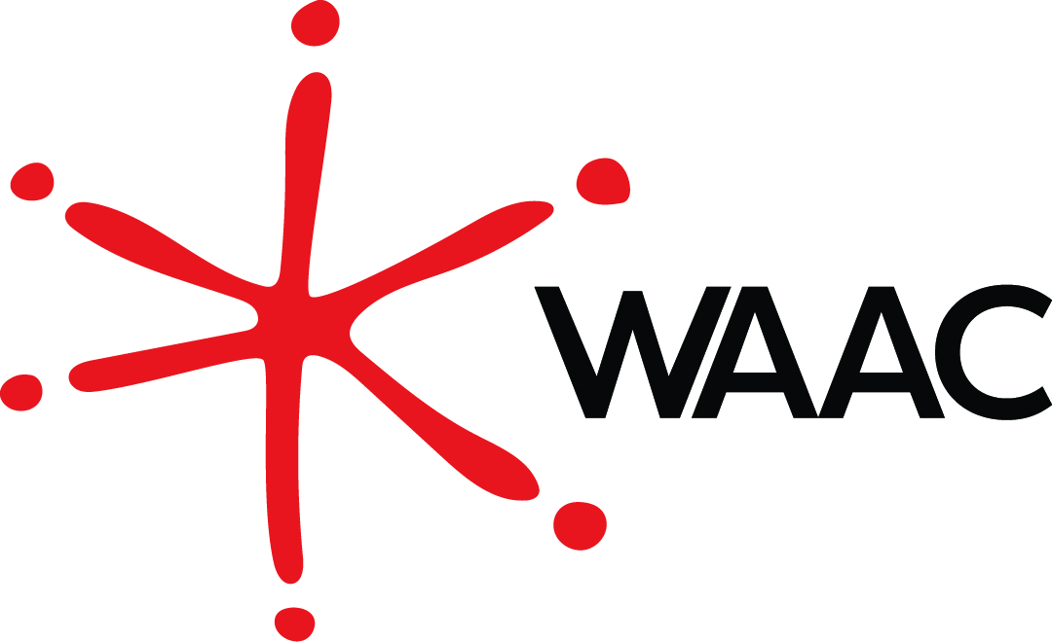

Membership Application/Renewal

2021/2022

☐ New Application ☐ Renewal ☐ Change of Address

Organisation’s Name (if applicable)
First Name Surname Pronouns
Partner’s Name (Couples Membership only)
Address

Suburb State Postcode
Telephone Email

Fees
☐ Individual $30 ☐ Couples $50 (both Parties are full members) ☐ Volunteer $20
☐ Corporate $100 ☐ Concession/Financial Hardship* $20 (please attach copy of student/pension card)

* If you are experiencing financial hardship, please write to us and we may reduce or waive the fee.

As a member of WAAC, I agree to abide by its constitution including the objectives set out therein. I also undertake to act in the best interests of the Council and not act in any way that will be detrimental to the interests of the organisation and its members.

Signature

Donation: Please tick if you would like to support WAAC with a donation

☐$10 ☐$20 ☐$50
☐$100 ☐$200 ☐$500
☐Other (please specify)

Payment Options
☐ Cheque ☐ EFT Please transfer the relevant fee to the bank account indicated below:
Name Western Australian AIDS Council Inc
Bank BSB 066-000
Bank Acc 13174746
Description Include the word ‘Member’ and your last name
Credit Card
☐ Visa ☐ Master Card Number
The last three digits next to the

Card Security Number
signature on the back of the card
Name as it appears on the card

Expiry Date /
Signature Today’s Date
/ /

Please find below the Objects of the Association:

(a) Recognising the unique nature of the HIV epidemic, and in partnership with our community, to continue to:

(i) Lead the Western Australian community response to eliminate new HIV transmissions, HIV- related stigma and the adverse social and health impacts of HIV, BBV and other STIs.

(ii) Honour and build upon the rich history of the Council’s commitment to be bold, innovative and responsive in serving and partnering with our community.

(iii) Improve health and wellbeing outcomes for people living with or affected by HIV.

(iv) Provide support through benevolent assistance programs, to people living with HIV, including direct financial assistance where appropriate.

(b) To achieve the most effective public health outcomes generally by:

(i) Promoting and delivering inherently empathetic and compassionate human services that are evidence-based, holistic and person-centred.

(ii) Influencing public and social policy, practice and research.

(iii) Representing the interests of a diverse and inclusive community.

(c) To educate communities and develop partnerships by:

(i) Providing accurate and relevant public health information and research via multiple platforms.

(ii) Effectively engaging within communities to empower and enable individuals to make informed decisions for themselves.

(iii) Positioning the Council to adapt and expand its role locally, nationally and regionally.

(d) To reduce and prevent harm by:

(i) Utilising expertise and adaptive models of care to respond to emerging issues, employing a harm- reduction framework.

(ii) Innovating, leading and excelling in the creation and delivery of services that embody best practice principles.

For New Memberships Only (Please note that you are required to have your membership application proposed and seconded by two current Members. If this is not possible, please provide a short statement of intent regarding why you wish to become a member).

Membership Proposed by Name Signature
Membership Seconded by Name Signature

Please return this form to PO Box 1510, West Perth, WA 6872 or alternatively it can be emailed to hello@waac.com.au

